'components' => [

// . .

'urlManager' => [

'enablePrettyUrl' => true,

'rules' => [

'home' => 'test/index',

'<alias:about>' => 'test/page',

'page/<alias>' => 'test/page',

]

],

// ..

],

After saving your changes, you should be able to browse the following URLs:

fe/home

fe/about

fe/page/about

/page/test

2. Try running the /home URL and you will get the following:

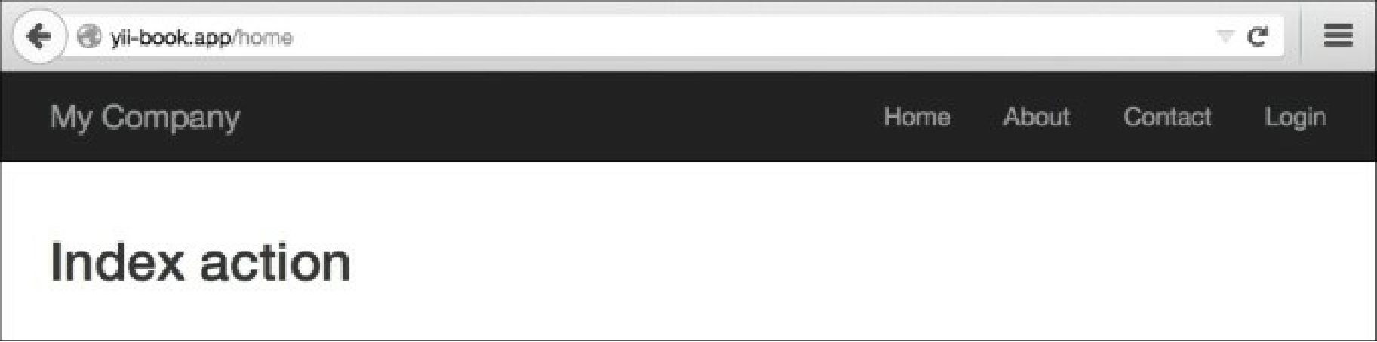

3. Then try running the /about page:

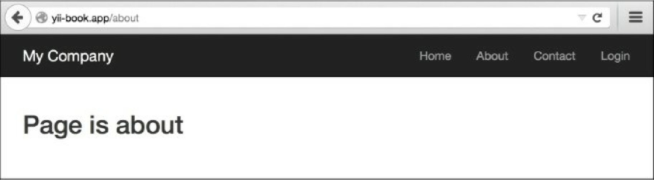

How it works...

Let’s review what was done and why it works. We’ll start with the right-most part of the first rule:

'home' => 'test/index',